CS 1632 – DELIVERABLE 3:

Automated Testing of a Web Application

Daniel Cowan

danielvcowan

<https://github.com/danielvcowan/D3>

Extra Credit 1 attempted

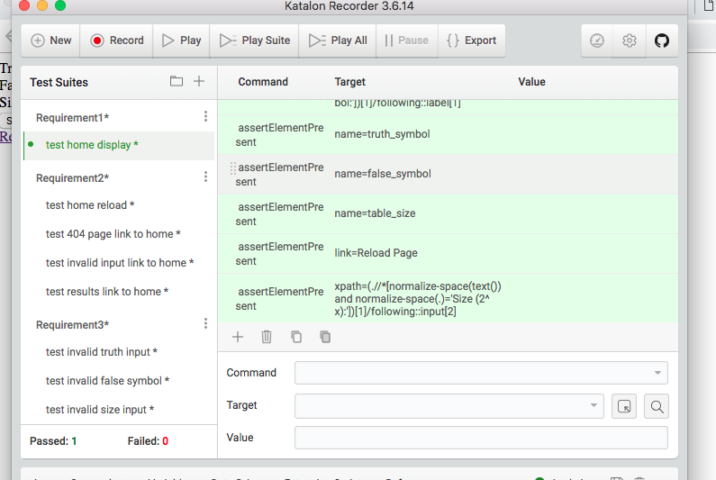

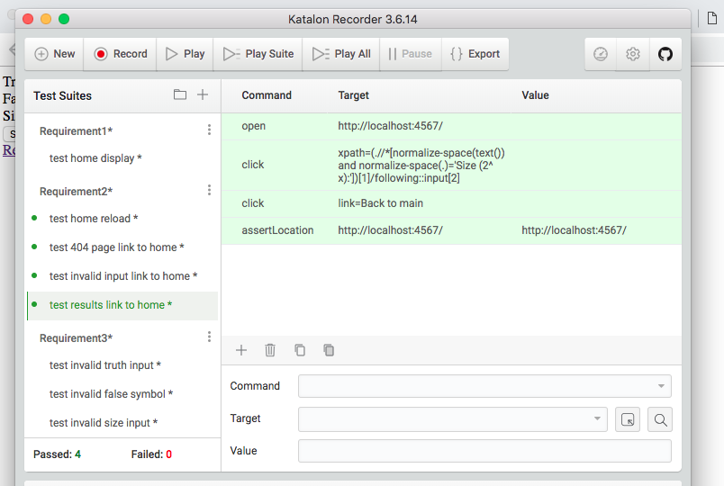

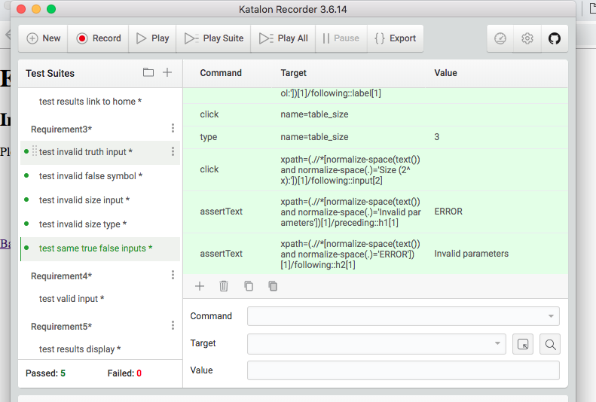

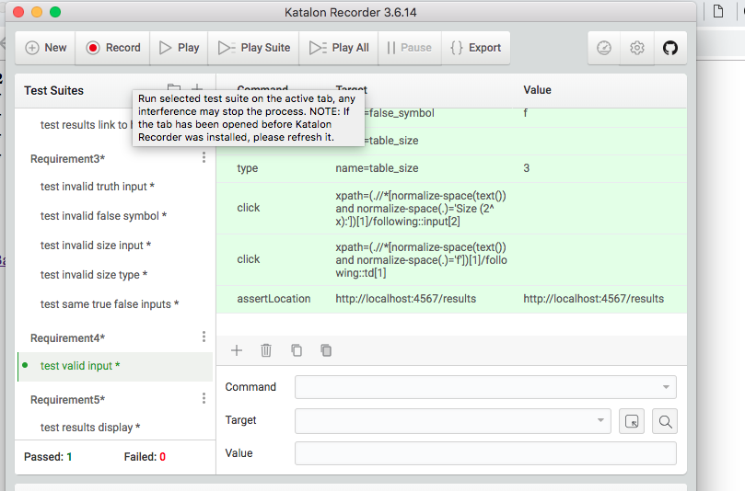

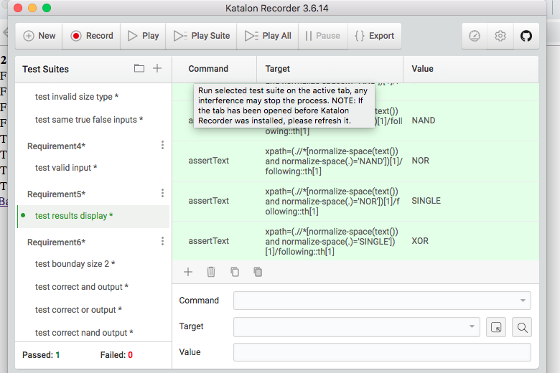

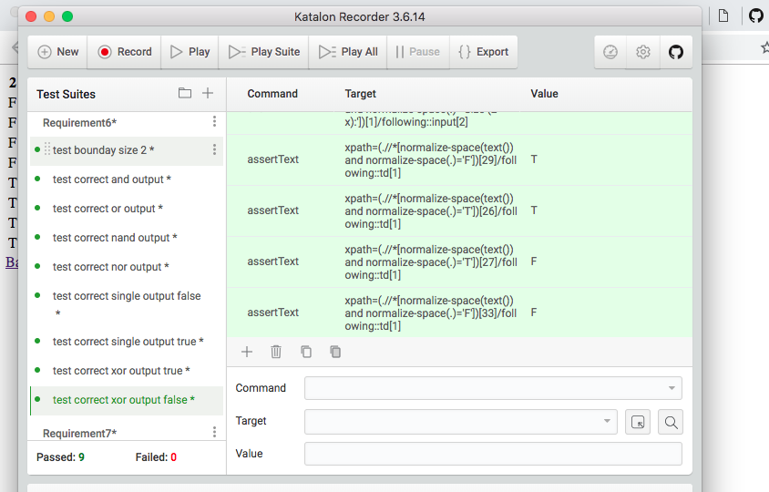

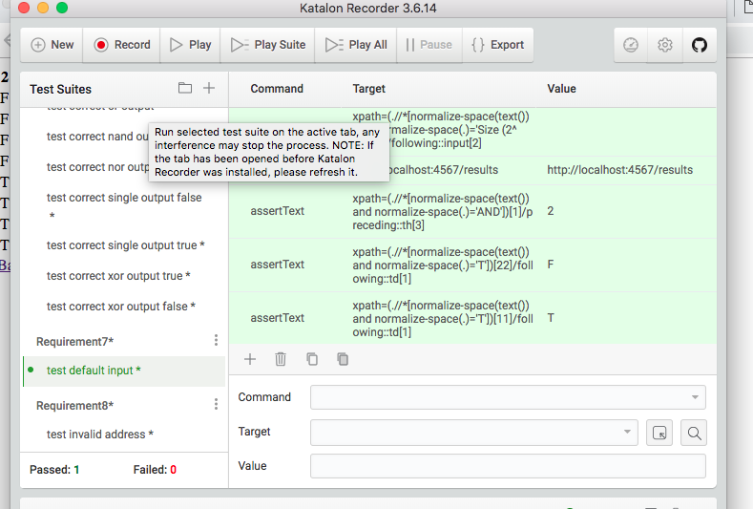

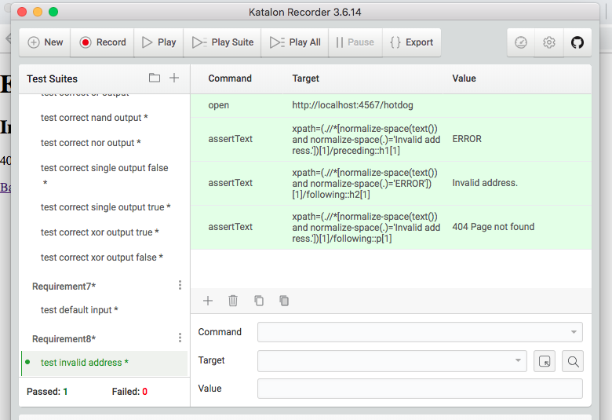

The difficulties I experienced during this project are as follows:

* I have very little experience in web programming, and no experience in building a Ruby backend with Sinatra. The challenges came in figuring out how to make the frontend and backend communicate with each other. I also had some trouble deciding what should go in the frontend versus the backend. Originally, I constructed my truth table entirely in the frontend, then realized that this was bad practice and changed it to the backend.
* Once the program was running as expected, I had some difficulty navigating through Katalon. I had never used this before and was absent during the Katalon lecture. Though online tutorials were extremely helpful, some time was wasted learning the testing environment.

**Traceability Matrix**

Requirement1: test home display

Requirement2: test home reload, test 404 page link to home, test invalid input link to home, test results link to home

Requirement3: test invalid truth input, test invalid false input, test invalid size input, test invalid size type, test same true false inputs

Requirement4: test valid input

Requirement5: test results display

Requirement6: test boundary size 2, test correct “and” output, test correct “or” output, test correct “nand” output, test correct “nor” output, test correct “single” output false, test correct “single” output true, test correct “xor” output false, test correct “xor” output true

Requirement7: test default input

Requirement8: test invalid address